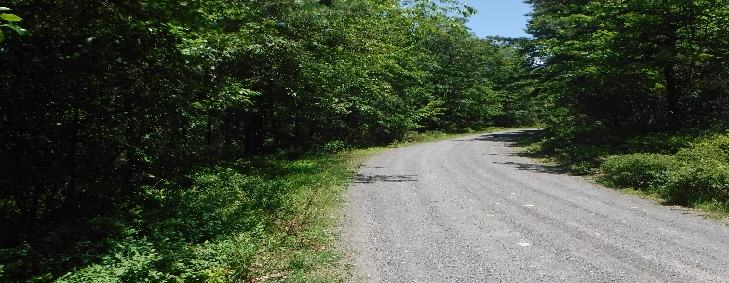 | PHELPS LOCAL ROADS BOARD  C/O 90 Tyes Road  Redbridge On P0H 2A0  705-663-1350  phelpslrb@gmail.com
2021 PHELPS LOCAL ROADS BOARD – Fall 2021 Update

Annually, the Phelps Local Roads Board along with the Ministry of Transportation develops a Work Program and annual Budget for Roads Maintenance. The process begins with a Roads Tour in early spring to identify issues and areas that require attention. Cost estimates are then developed for the potential work items, along with prioritization based on need and previous years’ maintenance work. Working with MTO, our annual Phelps Local Roads Board Budget is finalized for the fiscal year to inform our final Work Program (i.e. what we can afford to do); which culminates in an approved Work Program for the Phelps Local Roads Board for the fiscal year.
The contracts for this 2021 Work Program will be tendered as per government requirements, and we expect work will begin late summer for most of the gravel and ditching efforts. Full grading and the application of calcium will begin in early June to help contain the dust before the summer season.
As well, we have requested traffic counters on the 3 main township roads – Mountainview, North River and Songis Roads for early July, to help inform any future funding opportunities that may arise. (Note that a traffic counter on Songis Road for a one week period last August (during the pandemic and not on a long weekend) found traffic to be much higher than anticipated.)
Most of the feedback regarding road conditions from residents this year has been positive – in part thanks to our milder than normal winter conditions. We thank everyone for their patience.
If you have any questions, please contact the Phelps Local Roads Board.
Stay Safe!

Raymond Ouellette, Chairperson
Sandy Mannering, Trustee
Larry Douglas, Trustee

2021 PHELPS LOCAL ROADS BOARD APPROVED WORK PROGRAM
Songis Road
- “Children at Play” signs before and after Daycare - completed
- Replace entrance pipe at Trailer Park - completed
- Gravel to outside corner of S curve to improve grade on curve
- Gravel from Tyes Road to entrance on right at top of hill
- Remove leaning balsam and poplar trees to prevent fallen trees on road - completed
Sale Road
- Dig out frost heaved section and replace with gravel – completed
- Replace “Sale Road” sign at Songis – completed
Kelly Road
- Gravel to far side of Kelly’s
- Replace “Kelly Road” sign at Songis - completed
Rowley Road
- Gravel to end of road
- Ditch left side at mudslide - completed
Cedar Road
- Gravel to end of road
Pioneer Road
- Gravel from Knox’s Road to knoll
- Gravel to Spruce Road
- Replace culvert pipe at Spruce Road - completed
Spruce Road
- Gravel from before Bradley Creek to bush trail
Mountainview Road
- Gravel from Maple Road to end, where needed
Maple Road
- Gravel from first Turncircle to end
**Most of the 2021 Road work has been completed as indicated above.
***Please note: the gravel tender came back 3 times higher than expected. This was in part of large firms applying. Another tender is now in place hoping to attract more local contractors to bid. As we are now in September, not all the gravel maintenance may be completed this year.

